27.57: a) 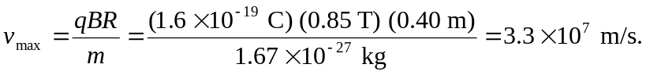

b) 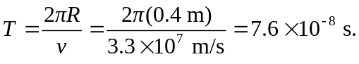
c) If the energy was to be doubled, then the speed would have to be increased by 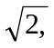 as would the magnetic field. Therefore the new magnetic field would be 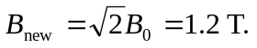

d)For alpha particles,
